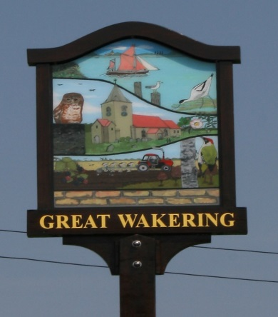
Great Wakering
Villager of the Year Competition 2026
Opens for nominations – 23rd February 2026
Closing date – noon 23rd March 2026
Proposer & Nominee must be a resident of Great Wakering.
Proposals should be a maximum of 150 words.

Nominee must not be politically active, hold public office or be paid to undertake the works they are nominated for.
For full rules and entry form visit:
http://www.greatwakering-pc.gov.uk
or Council Offices from 23/02/2026

